Key Vocabulary: ES 1 – Planning & Conducting Investigations

Volume – the amount of space occupied (taken up) by a substance. Solids are measured in cubic centimeters. Liquids measured in milliliters.
1 cubic centimeter = 1 milliliter

Mass – the amount of a matter in a substance. Measured in grams. Often confused with weight.

Density – a measure of how packed-in a substance is. Density always equals mass divided by volume and is always expressed as a combination of those two units, such as grams per milliliter (g/mL).

Variable – something that could change during an experiment

Manipulate – to force something to change on purpose

Independent Variable – the factor, condition, or “thing” you change on purpose during an experiment to “see what happens.”

Dependent Variable – the “thing” that changed in response to changing the independent variable. It is the factor being measured in an experiment.

Constant Variable – something that is not allowed to change in an experiment

Control Group – A group outside of the experiment, not affected by the independent variable. Used as a measurement to compare the experiment against

Example: An experimenter (you) want to measure how different colors of light affects plant growth. You have 10 samples of the same type of plant. Each plant is exposed to a different color of light for 12 hours a day, and you are going to measure how much each plant grows every day.

“Color of light” is the independent variable.
“Plant growth” is the dependent variable.
“Type of plant,” “ Amount of water,” “Hour of light per day” are all constants in the experiment.
A set of plants growing in natural sunlight would be a control group for the experiment.

Line Graph – Often used to show a change over time. The independent variable is placed on the bottom (x-axis) and the dependent variable is on the side (y-axis).
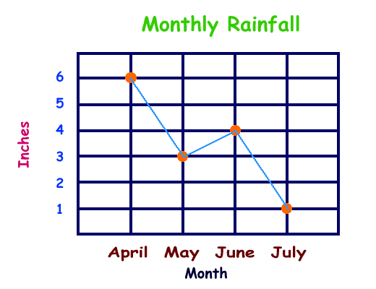

Frequency Distribution – A table or graph that shows how often something happens or a count for each category.
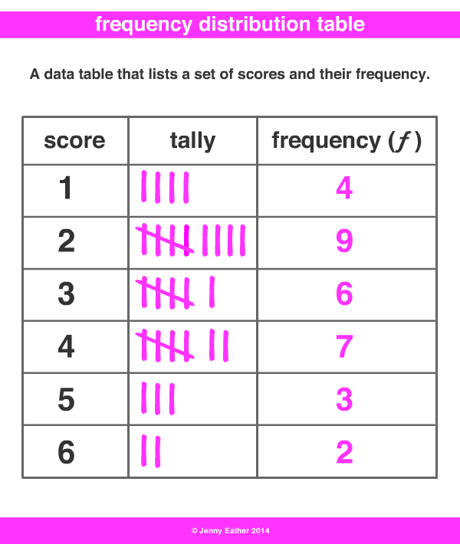

Bar Graph – A good way to show frequency distribution. Each category gets its own bar showing how often it happens.
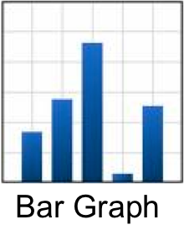

ES1 – Part 2 – Maps

Scale – A comparison of length on a map to actual distance. 1: 20,000 means one inch on the map covers 20,000 inches in the real world. The units don’t matter as long as they are the same units between the map and the real world. One centimeter on the map would be 20,000 centimeters in the real world.
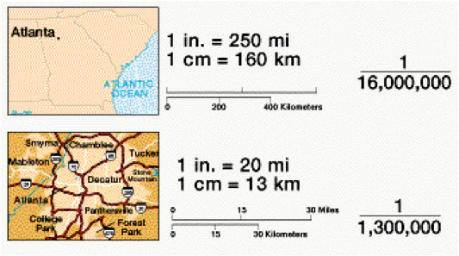
Topographic Maps – Maps that show what the surface of the earth is like including elevation changes, water features, buildings, etc.
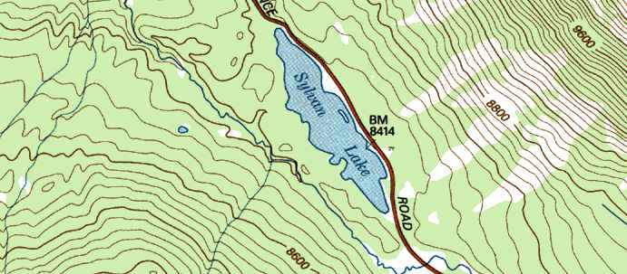

Satellite Imagery – Pictures of the Earth taken from space by satellites. These images are put together to make maps like Google Earth.

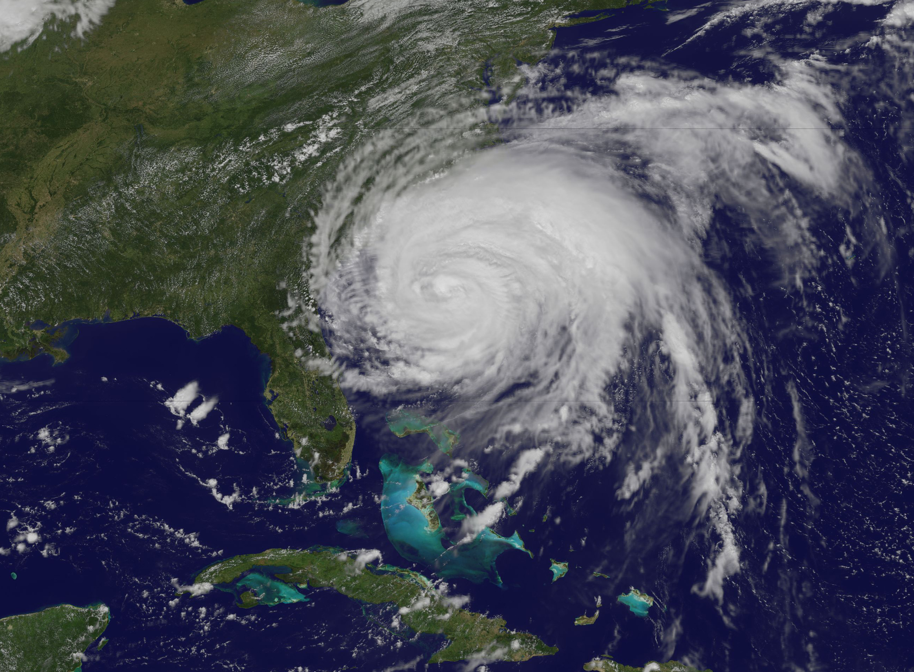

Elevation – A measure in meters or feet of how far above the average sea level a point on Earth is.

Altitude – A measure in meters or feet of how far up in the air something is.

Latitude – A measure in degrees of how far north or south of the equator a point on Earth is.

Longitude – A measure in degrees of how far east or west of the Prime Meridian a point on Earth is.

Minute – 1/60th of a degree. Degrees and minutes are used to show the longitude and latitude on maps

7.5 Minute Quadrangle Map – A small-scale map that covers 7.5 minutes of a degree of latitude. This is usually big enough to show a town and the surrounding area.

